**MEng Team 3 Workplace Charter**

**Statement of Purpose**

This document is intended for use as a set of common principles to provide guidance on interactions between team members and ensure everyone knows how they are expected to act throughout the duration of the project. It will be used as a reference point if disagreements arise between team members to ensure that all disagreements are resolved through the same process that all the team has agreed on prior to disagreements.

**Statements of Principles and Commitments**

The team will:

* Keep relationships professional
* Follow health and safety regulations
* Allow everyone the opportunity to input on each decision
* Have each individual take responsibility for their own time and deliverables
* Support each other, including checking in to try and remain aware of any issues with capacity before they develop

**Team Rules**

Core working hours where everyone is expected to be available, unless communicated otherwise, are from 11 AM to 4 PM Monday to Friday in semester time. Additionally, team members will be on campus during core hours 3 days a week minimum – Monday, Thursday, Friday unless agreed otherwise the week prior.

The language used in meetings and in all group communications is English.

Group members work outside of core hours so the agreement is that communication can be sent at any time between 7 AM and 8 PM but responses should not be expected immediately. Outside of University semester team members may be in different time zones so there are no limits on when messages can be sent, however as it is outside of semester replies should not be expected quickly.

The primary method of communication will be Microsoft Teams channels for all communication relating to the completion of the project, with the WhatsApp chat existing in case of any time sensitive communication out of core hours – there are not expected to be any and this will be used sparingly.

The team will meet a minimum of 3 times per week as a whole: once with the team supervisors and twice without (once early in the week on Monday or Tuesday, once later in the week on Thursday or Friday). These meetings will be in person wherever possible.

**Daily Activity Conflict Avoidance**

To ensure that everyone has an opportunity to speak, and to work towards creating a culture where we take criticism without it becoming a conflict, whenever an idea is proposed we will go round each member of the group to see what input or ideas they have.

In the meeting early in the week the group will take 5 to 10 minutes to reflect on what elements of the week before worked well and what we may look to change in the coming weeks. This is intended to be a space to have discussions around methods of working and see if any issues arose with how things were handled the week before. All team members have a pair they keep up to date on their work in case they fall ill or are unable to do their word.

**Conflict Resolution Flowchart**

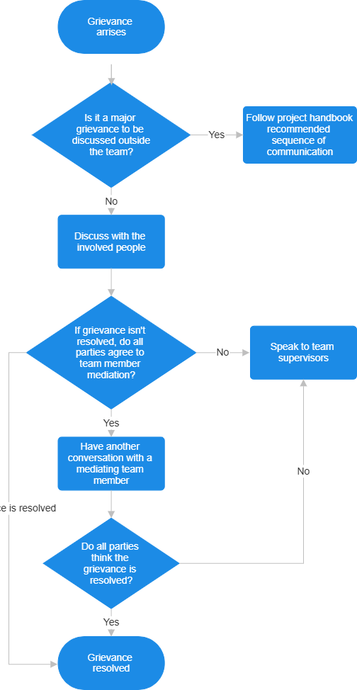If any member of the team has a grievance with another member the initial step is to try and discuss it with them away from the rest of the team. This should aim to be done with a clear idea of the source of conflict and, if possible, what the team members with a grievance would like to change to stop this happening again. If they do not feel able to do this, or if this does not resolve the issue, they can ask another member of the team to help mediate a conversation. If all parties do not agree on mediation in some form, including separate conversations with a mediator from the team and each person involved, the issue will then be raised with group supervisors by a 3rd party. If the team member feels that the grievance is a major concern they want to discuss outside their team, they should follow the Project handbook guidance on the Complaints Procedure. This outlines the sequence of communication as: Team Supervisors, 4th Year Project Coordinators, 4th Year Tutor and then the Director of studies. Issues can be raised for informal advice (not raised in writing) with the team supervisors or 4th Year Project Coordinators. For serious complaints the University report and support system (<https://www.reportandsupport.manchester.ac.uk/>) can be used.

Problem is

resolved

**Figure 1**: conflict resolution flowchart